Commercial Tobacco Prevention Program Regional Contractors
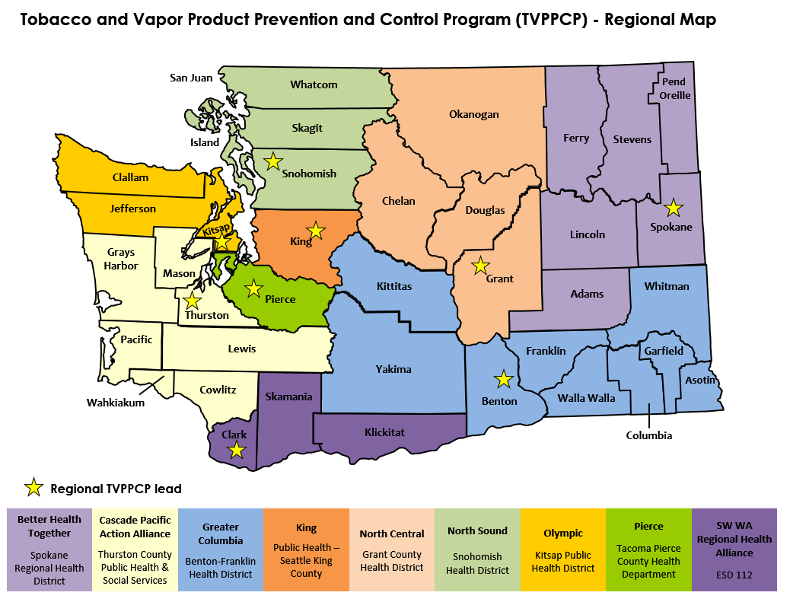
Better Health Together (Spokane, Adams, Lincoln, Ferry, Stevens, Pend Oreille counties)
Spokane Regional Health District
101 W College Ave
Spokane, WA 99201

AJ Sanders | Healthy Communities Specialist | 509-324-1596 | asanders@srhd.org

Cascade Pacific Action Alliance (Thurston, Mason, Grays Harbor, Pacific, Lewis,Wahkiakum, Cowlitz counties)
Thurston County Public Health & Social Services
412 Lilly Rd NE
Olympia, WA 98506

Kateri Wimsett | Health Education and Outreach Specialist | 360-867-2516 | WimsetK@co.thurston.wa.us

Greater Columbia (Kittitas, Yakima, Benton, Franklin, Walla Walla, Columbia, Garfield, Whitman, Asotin counties)
Benton-Franklin Health District
7102 W. Okanogan Pl
Kennewick, WA 99336

Vanessa McCollum | Public Health Educator | 509-460-4258 | vanessam@bfhd.wa.gov

King
Public Health-Seattle King County
401 Fifth Ave, Suite 1100
Seattle, WA 98104

Scott Neal | Tobacco Prevention and Marijuana Program Manager | 206-263-8197 | Scott.Neal@kingcounty.gov

North Central (Grant, Douglas, Chelan, Okanogan counties)
Grant County Health District
1038 W Ivy Suite 1
Moses Lake, WA 98837

Mariah Deleon | Health Educator | Office: 509-766-7960 Cell: 509- 770-5432 | mdeleon@granthealth.org

North Sound (Snohomish, Skagit, Whatcom, San Juan, Island)
Snohomish Health District
3020 Rucker Avenue, Suite 306
Everett, WA 98501

Pia Sampaga-Khim | Outreach and Preparedness Supervisor | 425-339-5279 | psampagakhim@snohd.org

Olympic (Clallam, Jefferson, Kitsap counties)
Kitsap Public Health District
345 6th St, Suite 300
Bremerton, WA 98337

Megan Moore | Healthy Communities Specialist | 360-728-2006 | Megan.moore@kitsappublichealth.org

Pierce
Tacoma-Pierce County Health Department
3629 South D St
Tacoma, WA 98418

Jessica Alvestad | Health Promotion Coordinator | 253-377-4242 | jalvestad@tpchd.org

SW (Clark, Skamania, Klickitat counties)
ESD 112
2500 NE 65th Avenue
Vancouver, WA 98661

Deb Drandoff | Director, Prevention and Youth Services | 360-952-3396  Cell: 509-703-4819 | deb.drandoff@esd112.org
Matt Cox | Community Prevention Project Specialist | 360-952-3458 | matt.cox@esd112.org

